
Climate Action Plan

The Aspire Academy


6 Month Plan Autumn 2025 to Spring – 2026
Jo.Pettifer@letsgozero.org

Your school’s carbon baseline: 539.79 t CO₂e Calculation: March 2025
Notes: These figures are to be used as an indicative estimation. Your baseline calculation was made 6 months into your first year’s plan – as such this plan is for 6 months, after which, a 2nd calculation will be made and a full year plan created accordingly.

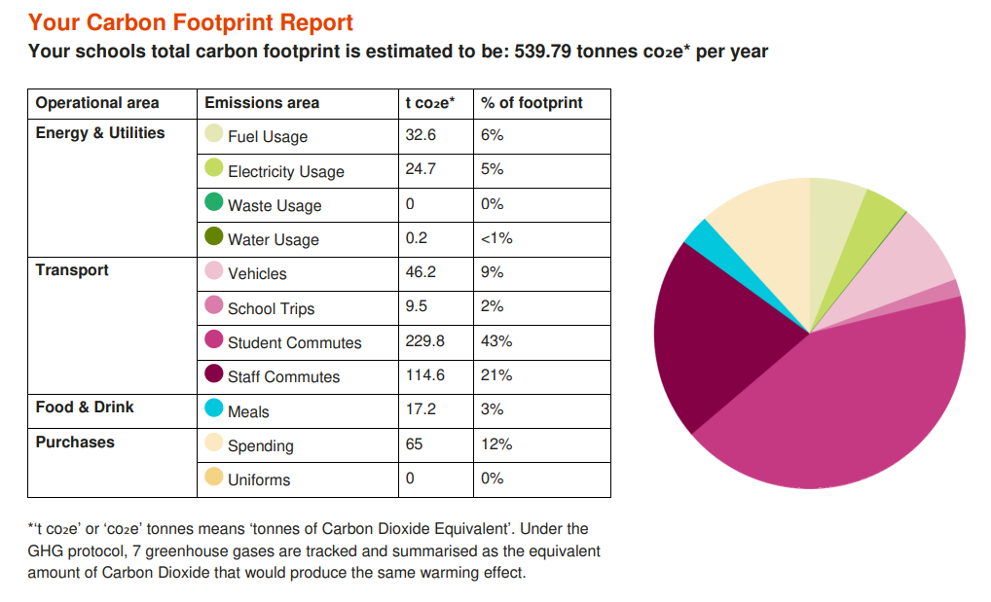
GET STARTED
ACTION | TIMEFRAME | STAKEHOLDERS | NOTES | TRACKER
Sign up to the Let’s Go Zero campaign  By joining this campaign, your school confirms that it is taking action now to reduce its own carbon impact, and that it demands the UK Government help all schools reach this goal by the end of the decade. | Start: Oct 24  Review: N/A | Aspire Staff/Let’s Go Zero | Completed | Complete
Calculate your school’s carbon footprint using Count Your Carbon  This free digital tool allows you to calculate the carbon footprint for your educational setting and gives you a baseline against which to measure progress, year on year. | Start: March 25  Review: March 26 | Jo Pettifer and Louise Laing | This has been calculated and a full set of figures can be inputted in March, when we have 12months of data. | Review March
Add sustainability plans, projects and successes to your school website and share through wider communications  Celebrate your school’s climate action on your website, in newsletters, social media, local press, and events to showcase your successes and involve the wider community. Use the Let's Go Zero comms pack to do this. | Start: June 2025  Review: Oct 25 | Lewis Thomas and Richard Rainbird-Hitchins | Promotional parts shared through Social Media  Re-share information online and share with Stakeholders | In Progress
Progress Key
Not Started
In Progress
Stalled
Complete
Climate Action Plan history
Last reviewed: | 11th Sept 2025

= = high carbon reduction actions
Overall projected carbon savings: TBC%

1. Decarbonisation and Energy Efficiency

Calculating and taking actions to reduce carbon emissions and becoming more energy efficient
ENERGY – BUILDINGS AND RETROFIT
ACTION | TIMEFRAME | STAKEHOLDERS | NOTES | TRACKER
Monitor energy use on a regular basis through dedicated platforms  Use an energy monitoring platform – West Mecia Energy MyWME to visualise and understand your energy usage. Use the data to look for patterns in day-to-day energy consumption and assess your energy baseload (how much energy you use continually). Armed with this information, you can decide where and when is best to target energy savings. If you are already sending your energy data to your provider, get in touch with them and ask them for access. | Start: 12th Sept 25  Review: Ongoing TBC | Louise Laing and West Mercia Energy | Your LGZ advisor has been in contact with West Mercia Energy who have noted the following:  12/9/25  “We had identified a communications issue with the AMR showing static reads some time before that and referred school contact details to Total Energies to investigate. Total have been gathering manual reads for billing. We have chased the metering team several times, and will follow this up.” | In Progress
★ Optimise your BMS/BEMS settings and ensure your heating and hot water systems have efficient timings and temperatures set  18ºC is the general recommendation for classroom temperatures, whilst hot water coming out of taps should be no higher than 43ºC (stored at 60ºC). Experiment with your heating schedule while maintaining comfort - running it one hour less per day or reducing temperatures by 1 degree can cut annual heating costs by 5–10%, according to the DfE. | Start: Sept 25  Review: TBC | Lousie Laing and The Aspire Site Team | When you have accurate monitoring in place, ensure your BMS is adapted accordingly. | In Progress
ENERGY – BEHAVIOURAL CHANGE
ACTION | TIMEFRAME | STAKEHOLDERS | NOTES | TRACKER
Take part in a switch off campaign  Take part in a switch off campaign, e.g. Switch Off Fortnight. Aim for 10% reduction of energy use (the typical amount saved by participating schools). Running campaigns before the holiday period (such as a summer switch-down) can lead to reduced energy use over the holiday period. | Start: Sept 25  Review: Ongoing for this academic year | Site Team at Aspire and wider staff community  Louise Laing and  Richard to oversee. | Stickers needed for walls in offices and classrooms- Lousie Laing to order  Richard Rainbird-Hitchins to launch to staff | In Progress

FOOD
ACTION | TIMEFRAME | STAKEHOLDERS | NOTES | TRACKER
Have separate food waste bins in all areas where food is prepared or consumed and collections in place  New waste regulations require all schools to separate food waste from general waste. Contact your waste supplier to organise food waste collections separately in line with 31st March 2025 legislation changes so that it can be diverted to anaerobic digestion plants. This could lower your waste disposal bills. Organise food waste caddies for all appropriate spaces. | Start: May 25  Review: Ongoing | Sue- Canteen Manager  Site team to support | Embed the best practice started in 2025  Richard Rainbird-Hitchins – To remind staff | Complete

TRANSPORT
ACTION | TIMEFRAME | STAKEHOLDERS | NOTES | TRACKER
Encourage staff to carpool  There are many apps that can help with this, or alternatively a simple sign-up sheet in the staff office works well. | Start:  Review: |  | Add an additional Car Pool space in the car park. Consider an incentive for staff who log X amount of shared trips via the QR code (e.g. coffee voucher)
(Consider) Install EV charging points  Install EV charging points in your car park for staff or parents and charge for usage. | Start:  Review: |  | Survey staff to find out potential demand then consider funding/ revenue potential – see our Let’s Go Guide.

2. Climate adaptation and resilience
Taking actions to reduce the risk of flooding and overheating and to future-proof scarce resources for potential shortages

ADAPTATION AND RESILIENCE
ACTION | TIMEFRAME | STAKEHOLDERS | NOTES | TRACKER
Subscribe to receive Heat Health Alerts and write a heatwave policy  Subscribe to the UK Health Security Agency's (UKHSA) Heat-health Alert Service. Familiarise your staff with updated DfE guidance on hot weather. Write a heat wave policy to address issues such as uniform, PE, suncream and outdoor learning. Consider adopting the joint union heatwave protocol including short-term, medium term and long-term measures. | Start:  Review: |  | Chrissi Taylor (Governor) to support in reviewing these policies.

3. Biodiversity and Green Infrastructure
Creating habitats and adopting practices that will enhance species diversity on the school estate and beyond

NATURE
ACTION | TIMEFRAME | STAKEHOLDERS | NOTES | TRACKER
Create accessible outdoor spaces that enable students to connect with nature  Identify areas in your school grounds where students can connect with nature. Ideally spaces with natural shade, space for seating and suitable access. | Start:  Review: | SENDco leading on this | Further your plans to have a designated Green Space

4. Climate Education, Green Skills and Green Careers
Ensuring the education you provide gives knowledge-rich and comprehensive teaching about climate change, and that your teaching staff feel supported to offer this

CULTURE
ACTION | TIMEFRAME | STAKEHOLDERS | NOTES | TRACKER
Set up an Eco Club or Eco Council for pupils to lead on sustainability initiatives  Establish a student Eco-Club or Eco Council. Consider inclusivity and longevity of projects so that as many students as possible can take part throughout their time at school. | Start:  Review:
Provide CPD opportunities for staff on sustainability  Investigate appropriate CPD opportunities for staff, e.g. sharing existing sustainability related content and developing skills through Carbon Literacy Training , Climate Fresk or our own Let's Go Zero session that can be delivered in person at staff INSET or remotely. | Start:  Review: |  | National College Annual training
Apply for funding  Submit an application for funding for one or more of your projects. Your CAA can share appropriate funds and grants where available. | Start:  Review: |  | Tesco Stronger Starts with Groundwork  - up to £1,500  - funding to implement a school community nature space with plenty of learning opportunities  - open for applications  - https://www.groundwork.org.uk/grants_tesco-community-grants/  Ford Britain Trust (you will need to check if your location is eligible)  £250–£3000  - supports projects focused on education, the environment, children, disabled people and youth activities that provide clear benefits to local communities close to Ford’s locations  - https://www.ford.co.uk/experience-ford/news/ford-britain-trust  Ernest Cook Trust: Outdoor Essentials Grant  £500  - awarded to UK state-funded primary and secondary schools to help get their students learning outdoors  - https://ernestcooktrust.org.uk/what-we-do/everything-outdoors/outdoor-essentials-grant/  Evolve Get Out! Grant  £500  - monthly awards for equipment, training, travel or resources to facilitate outdoor learning in schools  - https://www.evolveadvice.co.uk/grants  OurEcho Challenge (would need to link the veg bed plans with an action plan)  win prizes of up to £5,000  - STEM contest where youth-led teams identify threats to natural resources in their communities, develop an innovative solution and then submit an idea for their action plan to win prize money  - http://uk.ourechochallenge.org

CURRICULUM
ACTION | TIMEFRAME | STAKEHOLDERS | NOTES | TRACKER
Share best practice and ideas internally  This could include ensuring that sharing sustainable practices is on the agenda at curriculum meetings, departmental debriefs and teaching collaboration strategies. It could also involve CPD opportunities, tips in staff meetings, a peer observation focus, school bulletins and newsletters. | Start:  Review: |  | Share those “little wins” regularly




www.letsgozero.org

Ashden is registered in England and Wales as a company limited by guarantee.
Registered number: 05062574/ Charity number: 1104153
The Peak, 3rd Floor 5 Wilton Road, London, SW1V 1AP

