KS4 Food and Nutrition Autumn Term 1
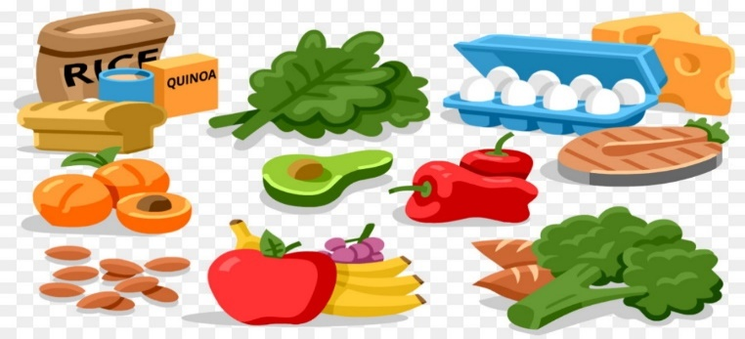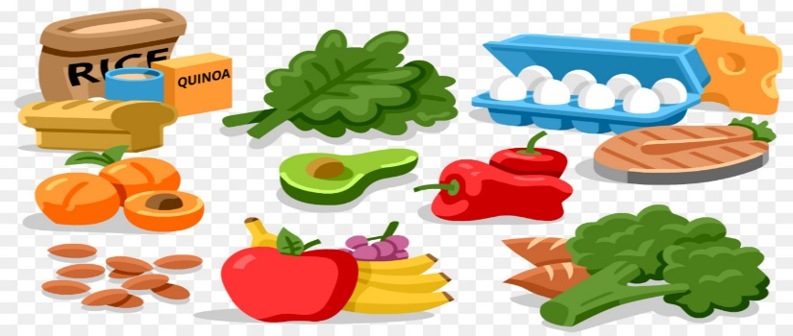

Unit 1 Introductory awareness of the importance of healthy eating and drinking for adults

Week | CACHE L1  Nutrition & Health
1  2  3  4 | LO1 Understand the importance of healthy eating  Task 1: Design a poster on the importance of healthy eating. (1.1, 1.2, 1.3) Your poster must include:  - what a balanced diet means  - examples of the effects a poorly balanced diet could have on your health  - examples of how food can contribute to helping you stay healthy
5  6  7 | LO2 Understand the importance of drinking enough to stay healthy  Task 2: Design a leaflet on the importance of drinking enough to stay healthy. (2.1, 2.2, 2.3, 2.4) Your leaflet must include:  • the recommended daily fluid intake to stay healthy  • examples of how drinking the recommended daily amount of fluid helps you to stay healthy  • effects on health of not drinking enough fluid  • signs of not drinking enough fluid  Task 3: A poster or leaflet is a good way to encourage people to eat and drink well to stay healthy. List below examples of other ways you can inform and encourage people to eat and drink well. (1.4, 2.5)

KS4 Food and Nutrition Autumn Term 2
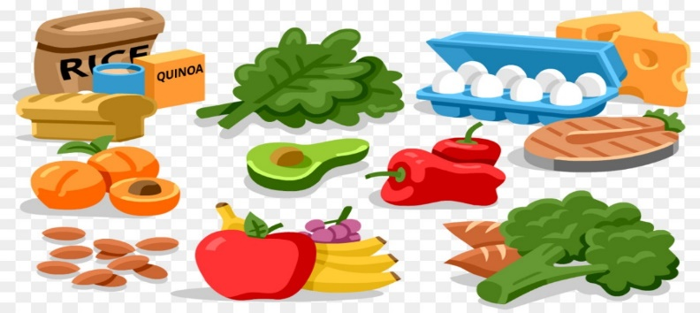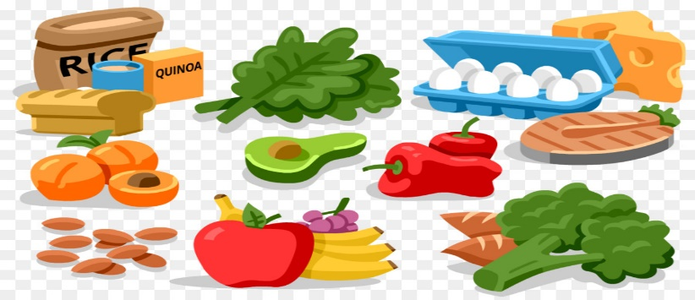

Unit 2 Planning healthy diets

Week | CACHE L1  Nutrition & Health
1  2 | LO1 Understand influences on own diet  Task 4: Many things can affect how we choose which food to eat. Identify 5 influences on food choices. (1.1)  Task 5: Now let’s look at your own food choices. List your favourite foods and explain what influences affect your food choices? (1.2)
3  4 | LO2 Be able to plan healthy diets  Task 6: (2.1, 2.2) You will need to:  • plan a one-day healthy diet for yourself. Include any dietary requirements where necessary  • plan a one-day healthy diet for a child, teenager or adult. Include any dietary requirements where necessary
5  6  7 | LO3 Be able to make healthy choices from menus  Task 7: Eating a healthy diet shouldn’t stop you from dining out. Use the sample menu below to pick a 3-course meal of healthy choices. (3.1)  Task 8: State how your choices will help contribute to a balanced diet. (3.2)

KS4 Food and Nutrition Spring Term 1
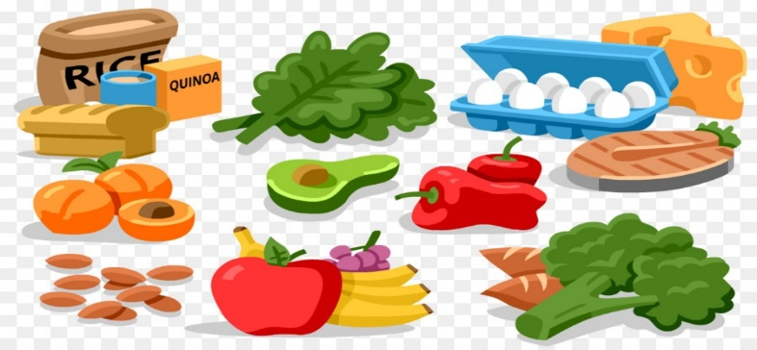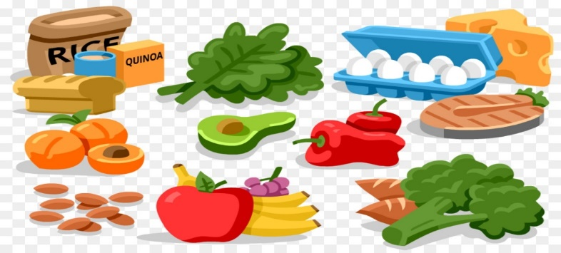

Unit 3 Understanding eating disorders

Week | CACHE L1  Nutrition & Health
1  2  3 | LO1 Know about different eating disorders  Task 9: There are varying types of eating disorder, each with their own symptoms and effects on health. (1.1, 1.2, 1.3)  Complete the table with 3 examples:  • Type of eating disorder  • Signs and symptoms  • Short-term effects  • Long-term effects
4  5 | LO2 Understand the connection between food and feelings  Task 10: Our feelings can affect our food choices. Identify the connections between food and feelings. (2.1)  Task 11: Outline why abnormal eating habits may develop. (2.2)
6  7 | LO3 Know how to access information and support related to eating disorders  Task 12: What further information and support is available relating to eating disorders? (3.1)

KS4 Food and Nutrition Spring Term 2
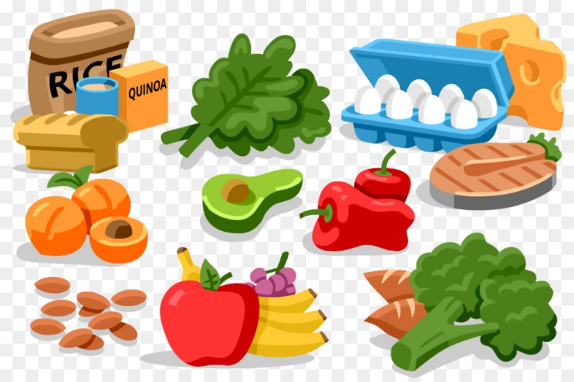

Week | BTEC L1  Home Cooking Skills
1 | Introduction to Assignment 1  Task 1-Planning your two course meal  Assessment criteria 1.1  Brainstorm starters
2 | Task 1-Planning your one course meal AC 1.1  Brainstorm main courses  Brainstorm desserts
3 | Task 1-Planning your one course meal AC 1.1  - Identify recipes for a two course meal  - List ingredients needed for the meal
4 | Task 1-Planning your one course meal AC 1.1  - List the equipment needed for the meal  - Include timings for the meal
5 | Task 1-Planning your one course meal AC 1.1  5a. Show how the meal contributes towards a balanced diet.
6 | Task 1-Planning your one course meal AC 1.1  5b. Why is the meal you have planned nutritious?  5c. Where will you source your ingredients from?

KS4 Food and Nutrition Summer Term 1

Week | BTEC L1  Home Cooking Skills
1 | Task 2 Demonstration of your practical skills AC 2.1-2.4  Trial Cook:  Select and prepare ingredients for recipes for a nutritious, one-course meal  Use cooking skills when following the recipes  Demonstrate food safety and hygiene throughout the preparation and cooking process  Apply presentation skills when serving the meal
2 | Task 2 Demonstration of your practical skills AC 2.1-2.4  Final Cook:  Select and prepare ingredients for recipes for a nutritious, one-course meal  Use cooking skills when following the recipes  Demonstrate food safety and hygiene throughout the preparation and cooking process  Apply presentation skills when serving the meal
3 | Task 3 Suggest ways to economise AC 3.1  Suggest three ways to economise at home
4 | Task 4 Passing on information AC 4.1  Show how you have used two different ways to pass on information to others about using cooking skills at home
5 | Assignment 1  Catch up
6 | Assignment 1  Catch up

