Year 10 Food and Nutrition Autumn Term 1
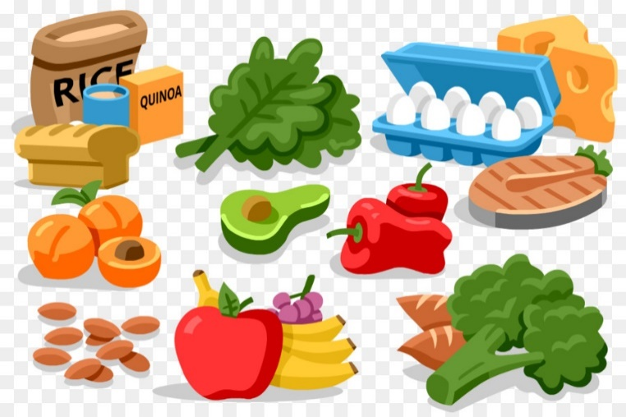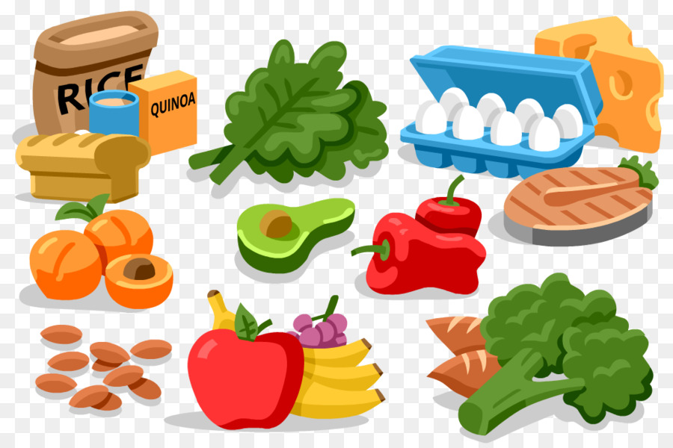
Unit 1 Explore Principles of Healthy Eating
Week | CACHE L2  Nutrition & Health
1 | Course introduction  Folder set up:  - Progress tracker  - Unit dividers
2 | 1 How diet is linked to health  1.1 Define the term ‘healthy diet’  1.2 Describe the difference between healthy diets of adults and children
3 | 1 How diet is linked to health  1.3 Outline the lifestyle diseases associated with an unhealthy diet  1.4 Identify the sources of energy from food  1.5 Identify the amounts of energy supplied by each source
4 | 1 How diet is linked to health  1.6 Estimate your own Basal Metabolic Rate (BMR)  1.7 Estimate your own Physical Activity Level (PAL)  1.8 Use the finding from 1.6 & 1.7 to determine your own energy requirements
5 | 1 How diet is linked to health  1.9 Identify factors affecting a person’s energy requirements  1.10 Outline the relationship between energy intake, energy expenditure & weight  1.11 Explain why it is important to control salt intake
6 | 1 How diet is linked to health  Catch up
Year 10 Food and Nutrition Autumn Term 2
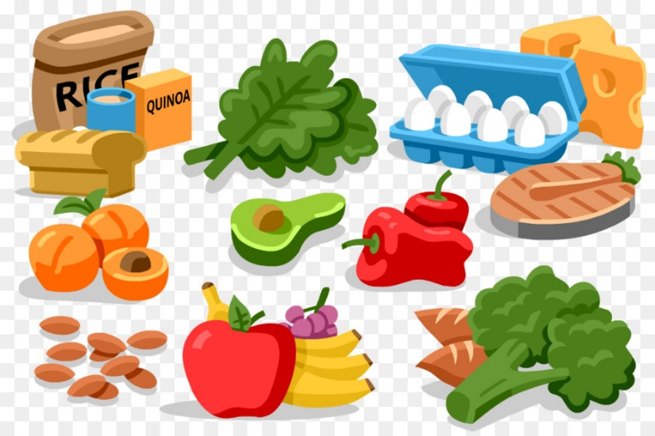
Unit 1 Explore Principles of Healthy Eating
Week | CACHE L2  Nutrition & Health
1 | 2 Understand the components of a healthy diet  2.1 Identify the 5 food groups  2.2 Identify foods belonging to each of the 5 food groups
2 | 2 Understand the components of a healthy diet  2.3 Give examples of current healthy eating advice
3 | 2 Understand the components of a healthy diet  2.4 Describe the importance of eating a wide variety of foods to provide a healthy diet
4 | 3 Know the nutrients in food and their role in maintaining health  3.1 Define the term nutrients  3.2 Describe why nutrients needed by the body
5 | 3 Know the nutrients in food and their role in maintaining health  3.3 Identify foods that are a good source of each nutrient
6 | 2 Understand the components of a healthy diet  3 Know the nutrients in food and their role in maintaining health  Catch up
Year 10 Food and Nutrition Spring Term 1
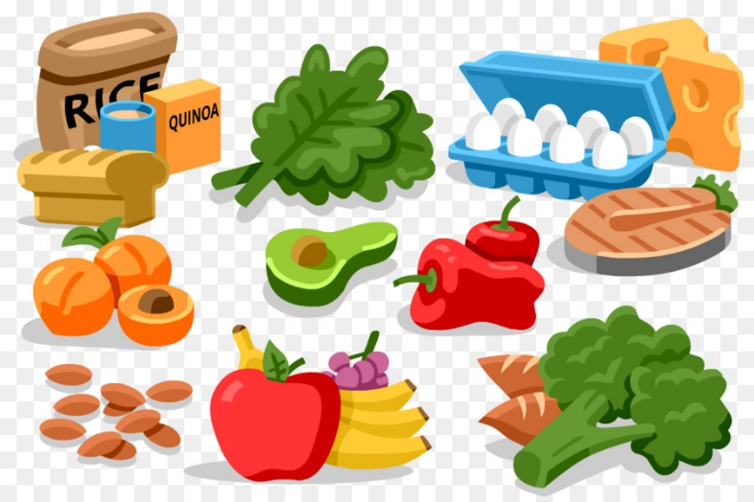
Unit 1 Explore principles of healthy eating
Week | CACHE L2 Nutrition & Health
1 | 3 Know the nutrients in food and their role in maintaining health  3.4 Describe the role of nutrients in maintaining health
2 | 3 Know the nutrients in food and their role in maintaining health  3.5 Describe the factors that influence how much of each nutrient a person needs
3 | 3 Know the nutrients in food and their role in maintaining health  3.6 Explain the importance of adequate fluid intake
4 | 4 Understand the principles of healthy food preparation  4.1 Identify the factors to be considered when planning healthy meals  4.2 Explain how a variety of cooking methods affects the nutritional values of foods
5 | 4 Understand the principles of healthy food preparation  4.3 Identify healthy food preparation methods for a range of types of foods
6 | 3 Know the nutrients in food and their role in maintaining health  4 Understand the principles of healthy food preparation  Catch up
Year 10 Food and Nutrition Spring Term 2
Unit 2 Consider nutritional needs of a variety of individuals
Week | CACHE L2 Nutrition & Health
1 | 1 Know the nutritional needs of children and young people  1.1 Plan balanced meals and snacks for a day for a chosen age group
2 | 1 Know the nutritional needs of children and young people  1.2 Explain why the meals and snacks chosen are appropriate
3 | 1 Know the nutritional needs of children and young people  1.3 Describe the factors influencing eating patterns of various different age groups  1.4 Identify energy requirements of various different age groups
4 | 1 Know the nutritional needs of children and young people  1.5 Identify the consequences of a diet lacking in iron  1.6 Outline the importance of calcium and vitamin D for bone development
5 | 1 Know the nutritional needs of children and young people  1.7 Identify good food sources of key nutrients for children and young people  1.8 Outline nutritional recommendations for children and young people
6 | 1 Know the nutritional needs of children and young people  Catch up
Year 10 Food and Nutrition Summer Term 1
Unit 2 Consider nutritional needs of a variety of individuals
Week | CACHE L2  Nutrition & Health
1 | 2 Know the nutritional needs of older people  2.1 Plan balanced meals and snacks for a day for an older person
2 | 2 Know the nutritional needs of older people  2.2 Explain how the meals and snacks chosen are appropriate for the person
3 | 2 Know the nutritional needs of older people  2.3 Describe factors influencing energy requirements of older people  2.4 Describe reasons why older people may be at risk of malnutrition
4 | 2 Know the nutritional needs of older people  2.5 Outline nutritional recommendations for older people
5 | 3 Understand special dietary requirements  3.1 Explain why people have specific dietary requirements
6 | 2 Know the nutritional needs of older people  Catch up
Year 10 Food and Nutrition Summer Term 2
Unit 2 Consider nutritional needs of a variety of individuals
Week | CACHE L2  Nutrition & Health
1 | 3 Understand special dietary requirements
2 | 3 Understand special dietary requirements  3.2 Identify the dietary requirements of 2 religious or ethnic groups
3 | 3 Understand special dietary requirements  3.3 Describe the different types of vegetarian diet
4 | 3 Understand special dietary requirements  3.4 Describe precautions to take when preparing food for a person with specific dietary requirements
5 | 3 Understand special dietary requirements  Catch up
6 | 3 Understand special dietary requirements  Catch up

Year 11 Food and Nutrition Autumn Term 1
Unit 2 Consider the nutritional needs of individuals
Week | CACHE L2  Nutrition & Health
1 | 4 Understand barriers to healthy eating  4.1 Outline how public confusion over healthy eating may prevent people from eating a healthy diet
2 | 4 Understand barriers to healthy eating  4.2 Identify how costs may prevent people from choosing a balanced diet
3 | 4 Understand barriers to healthy eating  4.3 Describe how accessibility may prevent people from choosing a balanced diet
4 | 4 Understand barriers to healthy eating  4.4 Describe how pre-prepared and convenience foods may prevent people from choosing a balanced diet
5 | 4 Understand barriers to healthy eating  4.5 Give examples of how individual lifestyle choices may prevent people from choosing a balanced diet
6 | 4 Understand barriers to healthy eating  Catch up
Year 11 Food and Nutrition Autumn Term 2
Unit 3 Use Food and Nutrition information to plan a healthy diet
Week | CACHE L2  Nutrition & Health
1 | 1 Understand food labelling  1.1 Identify nutritional information which must be provided on food labels
2 | 1 Understand food labelling  1.2 Identify the guideline daily amounts of fat, sugar and salt in an adult diet
3 | 1 Understand food labelling  1.3 Use nutritional information from food labels to determine if each of the foods is high, low or neither in terms of fat, sugar and salt content
4 | 1 Understand food labelling  1.4 Use nutritional information from food labels to calculate the energy provided by fat, protein and carbohydrate in each food
5 | 1 Understand food labelling  1.5 Outline ways in which food label claims and descriptions may be misleading
6 | 1 Understand food labelling  Catch up
Year 11 Food and Nutrition Spring Term 1
Unit 3 Use Food and Nutrition information to plan a healthy diet
Week | CACHE L2  Nutrition & Health
1 | 2 Understand food additives  2.1 Define the term food additives  2.2 Describe the main groups of additives and their functions
2 | 2 Understand food additives  2.3 Explain the benefits of food additives  2.4 Give examples of legislation surrounding the use of food additives
3 | 3 Apply the principles of healthy eating  3.1 Record your own food and drink intake for one week
4 | 3 Apply the principles of healthy eating  3.2 Compare your own food and drink intake against current healthy eating advice
5 | 3 Apply the principles of healthy eating  3.3 Outline the steps that you could take to make your diet more healthy
6 | 2 Understand food additives  3 Apply the principles of healthy eating  Catch up
Year 11 Food and Nutrition Spring Term 2

Week | BTEC L2  Home Cooking Skills
1 | Introduction to Assignment 1  Task 1-Planning your two course meal  Assessment criteria 1.1  Brainstorm starters
2 | Task 1-Planning your two course meal AC 1.1  Brainstorm main courses  Brainstorm desserts
Task 1-Planning your two course meal AC 1.1
- Identify recipes for a two course meal
- List ingredients needed for the meal
4 | Task 1-Planning your two course meal AC 1.1  - List the equipment needed for the meal  - Include timings for the meal
5 | Task 1-Planning your two course meal AC 1.1  5a. Show how the meal contributes towards a balanced diet.
6 | Task 1-Planning your two course meal AC 1.1  5b. Why is the meal you have planned nutritious?  5c. Where will you source your ingredients from?

Year 11 Food and Nutrition Summer Term 1

Week | BTEC L2  Home Cooking Skills
1 | Task 2 Demonstration of your practical skills AC 2.1-2.4  Trial Cook:  Select and prepare ingredients for recipes for a nutritious, two-course meal  Use cooking skills when following the recipes  Demonstrate food safety and hygiene throughout the preparation and cooking process  Apply presentation skills when serving the meal
2 | Task 2 Demonstration of your practical skills AC 2.1-2.4  Final Cook:  Select and prepare ingredients for recipes for a nutritious, two-course meal  Use cooking skills when following the recipes  Demonstrate food safety and hygiene throughout the preparation and cooking process  Apply presentation skills when serving the meal
3 | Task 3 Suggest ways to economise AC 3.1  Suggest three ways to economise at home
4 | Task 4 Passing on information AC 4.1  Show how you have used two different ways to pass on information to others about using cooking skills at home
5 | Assignment 1  Catch up
6 | Assignment 1  Catch up

