KS3 Food and Cookery Autumn Term 1
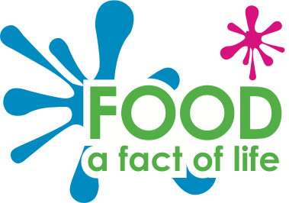
Food & Cooking
Week | Theory | Practical
1 | Expectations and Health & Safety | Rainbow Pasta Salad
2 | Eatwell Guide  5 a day  8 tips for a healthy diet | Savoury Rice
3 | Fruit & vegetables | Chocolate Chip Cookies
4 | How seasonality affects the price and availability of fruit & vegetables | Fajitas
5 | Cereals, potatoes, rice & other starchy foods | Mac ‘n’ Cheese
6 | Why choose wholegrain | Flapjacks

KS3 Food and Cookery Autumn Term 2

Week | Theory | Practical
1 | Where milk & dairy food comes from | Easy Pizza
2 | Where meat and fish come from and their importance in the diet | Spaghetti Bolognese
3 | The importance of eggs in the diet and the different egg farming methods | Mini Carrot Cakes
4 | The importance of alternative proteins in the diet | Jambalaya
5 | The sources and functions of fibre in the diet, including dietary recommendations | Stir-fry
6 | The importance of staying hydrated and the consequences of dehydration | Sausage Rolls
KS3 Food and Cookery Spring Term 1

Week | Theory | Practical
1 | Nutrients | Yeung Chow fried rice
2 | Energy | Quesadillas with bbq potato wedges
3 | Carbohydrates | American pancakes
4 | Protein | Toad in the hole with mashed potato
5 | Fat | Chicken and bacon pasta bake
6 | Vitamins | Muffins

KS3 Food and Cookery Spring Term 2

Week | Theory | Practical
1 | Minerals | Bread based pizza
2 | Energy Balance | Sausage casserole
3 | Energy needs:  Babies & young children | Cinnamon rolls
4 | Energy needs:  Teenagers | Meatballs and pasta
5 | Energy needs:  Adults | Paella
6 | Energy needs:  Older adults | Chocolate brownies

KS3 Food and Cookery Summer Term 1

Week | Theory | Practical
1 | Individual food choice:  Religion | Chicken tikka masala
2 | Individual food choice:  Diets without meat | Quorn noodles
3 | Individual food choice:  Food intolerences | Blondies
4 | Individual food choice:  Sports nutrition | Spanish sausage casserole with spicy potatoes
5 | Farming methods | Moroccan chicken with flatbreads
6 | Fair Trade | Red velvet tray bake

KS3 Food and Cookery Summer Term 2

Week | Theory | Practical
1 | Food labelling | Thai green curry
2 | Date-marks and storage instructions | Breakfast muffins with hash browns
3 | Cleaning and prevention of cross-contamination | Bakewell tarts
4 | Chilling, cooking and reheating food | Piri piri chicken and rice
5 | Food costing | Burgers and skinny fries
6 | Food marketing, advertising and promotion | Victoria sandwich cake

